**AIM: Implementation of C4.5**

**THEORY:**

The C4.5 algorithm is used in Data Mining as a Decision Tree Classifier which can be employed to generate a decision, based on a certain sample of data (univariate or multivariate predictors). C4.5 is the successor to ID3 and removed the restriction that features must be categorical by dynamically defining a discrete attribute (based on numerical variables) that partitions the continuous attribute value into a discrete set of intervals. C4.5 converts the trained trees (i.e. the output of the ID3 algorithm) into sets of if-then rules. This accuracy of each rule is then evaluated to determine the order in which they should be applied. Pruning is done by removing a rule’s precondition if the accuracy of the rule improves without it.

**SOURCE CODE:**

1. **INSTALLING CHEFBOOST FOR C4.5:**

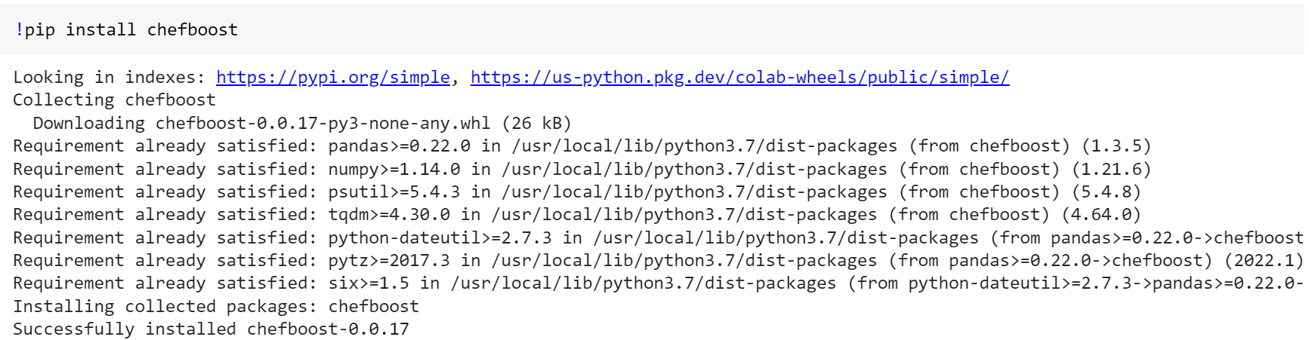

1. **IMPORTING LIBRARIES AND READING DATA:**



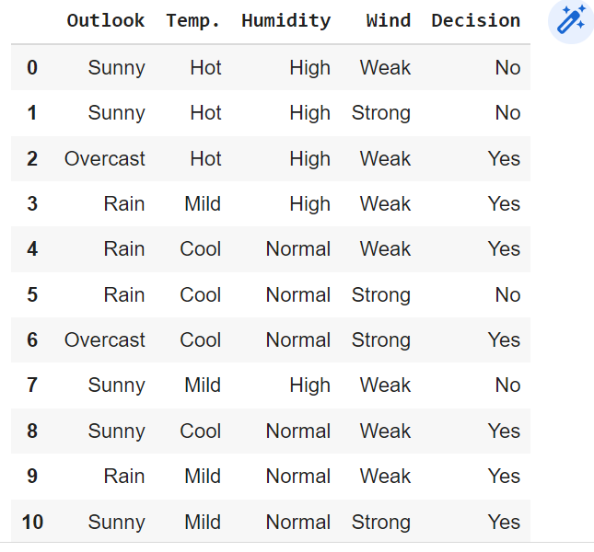

1. **BUILDING MODEL:**

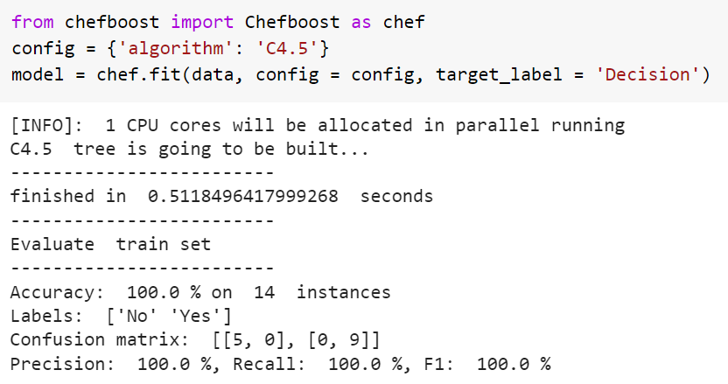

1. **PREDICTING VALUES:**

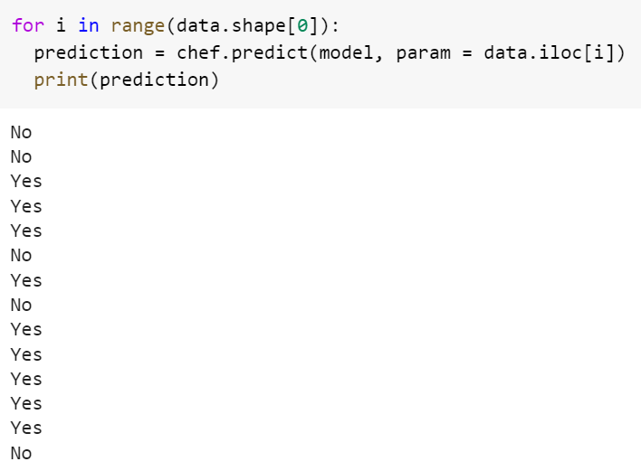

**CONCLUSUION:**

From this practical, I have learned the implementation of C4.5 in python.